

**CITIES SUPPORT PROGRAMME**

**NATIONAL TREASURY**

**REPUBLIC OF SOUTH AFRICA**

**Guidance Note for the Built Environment Performance Plan (BEPP) 2016/17 – 2018/19**

|  |  |
| --- | --- |
| **Title:** | Built Environment Performance Plans (BEPPs) Guidance Note for 2016/17 – 2018/19, issued on 21 October 2015 (First Draft issued 31/08/2015; Second Draft 17/09/2015). |
| **Purpose:** | To guide metros in the preparation of their BEPPs 2016/17– 2018/19 in terms of the annual Division of Revenue Act (DORA) as it relates to the Integrated City Development Grant (ICDG), Human Settlements Development Grant (HSDG), Urban Settlements Development Grant (USDG), Neighbourhood Development Partnership Grant (NDPG), Public Transport Infrastructure Grant (PTIG), and the Integrated Electrification Programme Grant (INEP). |
| **Target Audience:** | Metropolitan municipalities, specific national and provincial departments and State-Owned Companies |
| This BEPP Guidance Note for 2016/17 – 2018/19 must be read together with:-   1. DORA 2016, including the grant frameworks of the relevant infrastructure grants, and any policy related documents viz. A Policy to Govern the Expenditure of the USDG, May 2015. 2. ICDG Grant Framework in DORA 2016 and The Guidelines for the Implementation of the Integrated City Development Grant, May 2013, and as updated. 3. The Guidelines for Performance Indicators for the Metros in SA, May 2013, and as updated. 4. Concept Note for the Built Environment Value Chain and Progression Model, 23 September 2015 5. Guidance Notes, toolkits and other relevant documents relating the Neighbourhood Development Programme, <http://ndp.treasury.gov.za> 6. Framework for Spatial Investment in Human Settlements prepared by the CSIR 31 March 2015 for the Housing Development Agency, and as updated. Concept Document: National Human Settlements Spatial Plan, August 2014, and as updated. | |

**CONTENTS**

1. INTRODUCTION 3

2. FOCUS OF BEPPS 2016/17 – 2018/19 6

3. GUIDELINES FOR THE CONTENT OF THE BEPP 7

3.1 Completion, Refinement & Consolidation of Previous Focus Areas 7

3.2 Spatial Planning and Project Prioritisation 7

3.2.1 Spatial Targeting . .7

3.2.2 Precinct Planning 8

3.2.3 Project preparation for selected key catalytic urban development projects 9

3.2.4 Intergovernmental Planning and Sector Alignment 10

3.2.5 Developing a strategy for prioritised Integration Zone/s 12

3.3 Intergovernmental Project Pipeline 13

3.4 Capital Funding 14

3.5 Implementation 14

3.6 Urban Management 15

4. INSTITUTIONAL ARRANGEMENTS & OPERATING BUGETS 16

5. REPORTING AND EVALUATION 16

5. BEPP PROCESS AND TIMEFRAMES 17

6. GUIDELINES FOR CONTENT AND FORMAT REQUIREMENTS 19

Annexure 1: Built Environment Progression Model 23

Annexure 2: Integration Zones Matrix 28

Annexure 3: Catalytic Urban development Project Pipeline Template 29

|  |  |
| --- | --- |
| **Glossary** | |
| AFS  AG  BEPP  BEPM  BEVC  CBF  CIDMS  CIF  CSIP  CSP  DORA  HSDG  ICDG  INEP  SDBIP’s  MSDF  MTREF  NDPG  NDP  PPF  PTIG  SPLUMA  UNS  USDG | Annual Financial Statements  Auditor General  Built Environment Performance Plan  Built Environment Progression Model  Built Environment Value Chain  Cities Budget Forum  City Infrastructure Delivery Management System  Capital Investment Framework  Capacity Support Implementation Plan  Cities Support Programme  Division of Revenue  Human Settlements Development Grant  Integrated City Development Grant  Integrated National Electrification Grant  Service Delivery and Budget Implementation Plans  Metropolitan Spatial Development Framework  Medium Term Revenue and Expenditure Framework  Neighbourhood Development Partnership Grant  Neighbourhood Development Programme Unit  Project Preparation Facility  Public Transport Infrastructure Grant  Spatial Planning and Land Use Management Act 2013  Urban Network Strategy  Urban Settlements Development Grant |

# 1. INTRODUCTION

Through the last 3 years the economic and fiscal context required a response that included bold, new approaches to planning, programme preparation and financing, and implementation. The imperative for far deeper and more productive partnerships with investors, developers and households has become even more important now under current economic and fiscal realities, as well as the fact that urban spaces are a co-product of the interventions of government, firms and households.

**The purpose and role of the BEPP**

The BEPP is a requirement of the DORA in respect of infrastructure grants related to the built environment of metropolitan municipalities. It remains one of the eligibility requirements for the Integrated City Development Grant (ICDG). The ICDG is an incentive grant that rewards the application of infrastructure grants, as part of the total capital budget, toward catalysing spatial transformation through a spatial targeting approach at a sub-metropolitan level. The BEPP is thus also an instrument for compliance and submission purposes for the following infrastructure grants:-

The 2016/17 Medium Term Revenue and Expenditure Framework (MTREF) is the 3rd annual cycle of the built environment performance plans (BEPPs) and associated processes. The focus of the 2014/15 BEPP processes was on planning methodology for spatial transformation and in 201516 the focus shifted to packaging and accelerating the implementation of a pipeline of catalytic urban development projects within the integration zones. The work on defining the built environment outcomes and impacts, and the resultant indicators to measure spatial transformation started in 2013. In addition cities have spent time between 2013 and 2014 working out what support they required from the Cities Support Programme to assist them to achieve their spatial targeting goals and objectives, and this is reflected in their City Support Implementation Plan (CSIP).

The identification and planning of Urban Networks and Integration Zones was the key focus of the 2014/15 BEPP. Subsequently the 2015/16 BEPP guidelines encouraged the refinement and consolidation of the planning of urban networks and Integration Zones done the year before, and went a step further by requiring the identification, packaging and implementation of a pipeline of catalytic urban development projects within the Integration Zones. In addition there was a specific focus on the upgrading and development of informal settlements and other marginalised areas.

• ICDG - Integrated City Development Grant, Schedule 4B (supplements municipal budgets);

• USDG – Urban Settlements Development Grant, Schedule 4B (supplements municipal budgets);

• HSDG – Human Settlements Development Grant, Schedule 5A (specific purpose allocations to provinces);

• PTIG – Public Transport Infrastructure Grant, Schedule 5B (specific purpose allocations to municipalities);

• NDPG – Neighbourhood Development Partnership Grant

* Schedule 5B (specific purpose allocations to municipalities) Capital Grant;
* Schedule 6B (allocation-in-kind to municipalities for designated special programmes) TA;

• INEP– Integrated National Electrification Grant, Schedule 5B (specific purpose allocations to municipalities)

It should be noted that the BEPP is intended to contribute to and enhance existing statutory planning instruments and that it does not duplicate or replace them – see Diagram 1.

The Municipal Systems Act set out the requirements for the IDPs. The IDPs covers functional and institutional planning, as well as the Spatial Development Framework as regulated by SPLUMA. The Budget and SDBIP are requirements of the MFMA. The linkages between the plans are generally weak and the results of all of this planning seldom yields the outcomes and/or impacts that we seek as a nation or at the city level. The BEPP is a response to this challenge.

**Diagram 1: BEPP in relation to Statutory Planning Instruments**

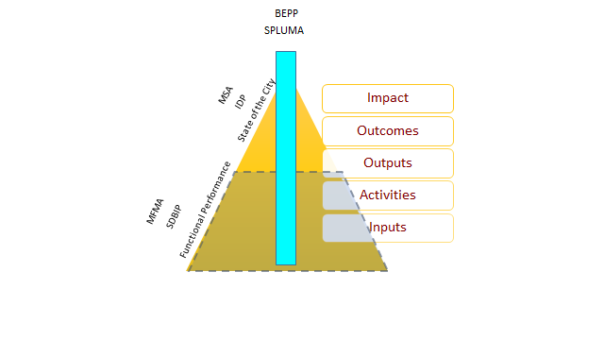

**Key concepts in the Spatial Planning Method**

The **spatial planning** method adopted by the BEPP is based on integrated, transit oriented development as articulated in the Urban Network Strategy. Four key concepts are critical to this approach: (i) outcomes-led planning; (ii) the Built Environment Value Chain; (iii) Prioritisation and Preparation; and (iv) Progression.

**Outcomes-led planning:** The BEPP planning process is **“outcome-led”,** responding to agreed indicators of and targets for improved built environment performance. Built environment performance will be assessed through **reporting and evaluation** of urban transformation outcome and impact indicators. These indicators are subject to ongoing refinement, as part of broader reforms to the reporting system being introduced by the National Treasury.

**The Built Environment Value Chain:** The BEPP is the plan and process that is informed by the Built Environment Value Chain(BEVC) as depicted in Diagram 2 below. The BEVC is an **intergovernmental process** or set of activities aimed at achieving the built environment objectives in cities. The BEVC activities are linked together in a logical sequence, and form part of a cyclical process rather than a linear process. *Please note that the built environment activities depicted in Diagram 2 links to the text in bold letters in this section. The format for the BEPP in Section 6 of these guidelines follows the logical sequence of the BEVC.*

These BEPP guidelines and previous iterations have consistently required effort from cities to adopt a results-based approach, to work in terms of a specific intervention logic (BEVC), to be guided by a specific planning method and that requires a behavioural change at the institutional level. Committing to how we measure results is intrinsic to the planning approach.

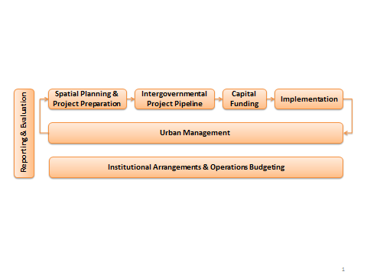

The Built Environment Value Chain (BEVC) is an **intergovernmental process** or set of activities linked in a logical sequence that is aimed at achieving the metropolitan built environment objectives.

**Diagram 2: Built Environment Value Chain (BEVC)**

The product of the planning approach is the identification and planning of Integration Zones that include an **intergovernmental project pipeline** (catalytic metro, provincial, national and SOC urban development projects) within the following targeted spaces:

* Integration Zones
* Marginalised areas (Informal settlements, townships and inner city areas)
* Growth nodes (commercial and industrial nodes)

This planning approach should clearly influence the allocation of **capital funding**, and result in service delivery **implementation**, which in turn requires **urban management** to protect and sustain public and private investment. The successful implementation of BEPPs relies on effective **institutional arrangements and budgeting for ongoing operational expenditures**. Sustained implementation and urban management should result in service delivery and spatial transformation that positively contributes to inclusive economic growth and the reduction of poverty and inequality over the long term.

**Prioritisation and preparation:** The **prioritisation of Integration Zones, informal settlements, marginalised areas and areas for growth** relative to other areas within the metro, and the resultant intergovernmental project pipeline will collectively support the achievement of targets associated with building more productive, inclusive and sustainable cities. The prioritisation of particular areas mentioned above does not translate into an exclusion of allocation of resources to other areas, although a substantial portion of resources should be allocated to the three categories of targeted spaces and this allocation should increase year on year.

Selected projects in the pipeline, i.e. non-standard, complex projects in terms of planning, design, funding, external financing, and operations need to follow a **rigorous project preparation approach** to ensure that the projects are designed from the outset with feasible and documented concepts, viable project funding structures, effective implementation and operational modalities, and for projects in the pipeline to collectively contribute to outcomes and thus impacts.

**Progression model:** The evaluation of the 2015/16 BEPP cycle identified issues of uneven quality and procedural rigour between cities. It recommended that a progression model be introduced to monitor the maturity and ongoing development of individual metros. The Progression Model enables a city to progress in terms of its capacities and capabilities, and encourages clear accountability for the ongoing strengthening of the BEPP process and outputs over time. It will also inform a more nuanced and responsive approach to providing support and incentives, as outlined in detail in Annexure A. This progression model and its implementation arrangements will be subject to further development over the next cycle.

# 2. FOCUS OF BEPPS 2016/17 – 2018/19

The work started over the last two years should be refined and consolidated. There are new focus areas for the 2016/17 MTREF which will enable cities to progress further along the Built Environment Value Chain and the Progression Model. The main focus areas for the 2016/17 MTREF BEPPs are:-

1. **Spatial Planning and Project Prioritisation**
   1. Spatial Targeting - Prioritization of Integration Zones, marginalised areas and growth nodes;
   2. Local Area Planning - Developing a strategy for the *prioritised* Integration Zone(s), Marginalised Areas and Growth Nodes and undertaking precinct planning within Integration Zones in consultation with provincial and national spheres as well as SOE’s;
   3. Project preparation for selected key catalytic urban development projects;
   4. Intergovernmental Planning and sector alignment;
   5. Developing a strategy for the Prioritised Integration Zone.
2. **Intergovernmental Project Pipeline and Capital Funding.** Improving intergovernmental funding alignment via the project pipeline. Effecting transformation in targeted spaces requires changes in funding approaches by the provincial and national spheres, as well as State Owned Enterprises;
3. **Implementation of the metropolitan pipeline of urban development projects;** and
4. **Urban management to protect and sustain public, private and household investment**.

These focus areas are elaborated on in sections 3.1 to 3.4 below.

# 3. GUIDELINES FOR THE CONTENT OF THE BEPP

The content requirements of the BEPP are explained in terms of the current issues; the requirements and expectations for 2016/17 in relation to the Draft and Final BEPPs; the tools that can be used, and the support available to cities.

## Completion, Refinement & Consolidation of Previous Focus Areas

In general some of the content in the last two BEPPs has either not been of sufficient quality, or been missing and all BEPPs have not clearly and explicitly demonstrated the intervention logic that drives the BEPP.

Requirements and Expectations

The work done to date over the last two years should be provided, completed, refined and consolidated as required in terms of the focus areas in the Guidelines for BEPPs over the last 2 financial years, including:-

1. The identification, refinement and consolidation of urban networks and Integration Zones;
2. Improved Transit Oriented Development (TOD) interfaces, particularly through the better alignment of public transport and housing programmes, especially public housing that will improve TOD, and transit investments aligned to Integration Zones.
3. The identification and packaging of a pipeline of catalytic urban development projects within Integration Zones;
4. The upgrading and development of informal settlements and interventions for other marginalised areas;

The Draft BEPP should identify and acknowledge:-

* Content that is missing, and when this content will be provided;
* Content that requires refinement and consolidation, and when this will be provided.

The Final BEPP should provide the content and/or provide a commitment (clear timeframe) as to when the content will be provided.

**SUPPORT**

City level implementation support is available on request via your National Treasury CSP Co-ordinator. The Department of Human Settlements has committed to working with the CSP on the issue of Informal Settlements to provide guidance and assistance to cities.

Tools

There is still a need from some cities to improve the quality of certain sections of the BEPP, or provide content for parts that were previously left out. Each city has received detailed written feedback from the National Treasury, specialist evaluations, and some sector and/or stakeholder inputs. Reference should be made to the BEPP Guidelines for 2014/15 and 2015/16.

## Spatial Planning and Project Prioritisation

### Spatial Targeting

The process of spatial targeting needs to be concluded at all scales to strengthen the project and intervention identification and prioritisation process. Most metros have completed the identification process but still need to refine these zones, and then prioritise the zones relative to one another.

Requirements and Expectations

1. Identify Informal Settlements and Marginalised Areas, Townships and Inner City Areas;
2. Identify Areas of Growth (commercial and industrial);
3. Identify Priority Integration Zone(s) -

The priority Integration Zone should be the focus of as many public sector role players as appropriate, aligning public sector investment to attract and incentivise firms and households to invest their resources in Integration Zones. It is possible to have more than one priority Integration Zone at a given point in time, but there should be clear prioritization between them in terms of relative resource allocation. The identification, planning, funding, implementation and management of Integration Zones must be reflected in the Integration Zone Matrix template as outlined in **Annexure 2**.

**SUPPORT**

The Neighbourhood Development Programme (NDP) will continue to provide technical assistance for refining the identification and prioritisation process. The Department of Co-operative Governance has already asked each metro to identify their priority Integration Zone so that they can rally support from the rest of the relevant government departments at the national and provincial spheres and also the SOCs. Public investment in high density residential development, both social housing and affordable housing in the priority Integration Zone would improve inclusivity – the CSP is currently supporting 3 metros to analyse dynamics in their property markets and identify obstacles that constrain the affordable housing market.

The Draft BEPP should have the Priority Integration Zone identified and the final BEPP should have the Integration Zone Matrix template completed.

Tools

Integration Zones should be prioritised relative to one another in terms of their ability to integrate marginalised areas with the more developed parts of the city space, i.e. according to the size and density of townships and informal settlements served by the identified Urban Hubs. The template for the Integration Zones Matrix is outlined in **Annexure 2**.

### Precinct Planning

Precinct Planning follows on from the identification of Integration Zone/s. This process is intended to yield a list of prioritised catalytic urban development projects which together would increase the potential for investment agglomeration.

Requirements and Expectations

Metros will be required to identify and prioritise precincts and undertake detailed precinct planning, project identification and project preparation, where relevant, in the prioritised Integration Zones.

The Draft BEPP should have the prioritisation completed for all three spatial targeting categories outlined in section 3.2.1, above. This should lead to the identification of key precincts in the Integration Zone, as well as any non-investment activities or interventions.

The Final BEPP should confirm: (i) the prioritised Integration Zone and the key precincts within the zone; (ii) the strategy for the Integration Zone and the two other spatial targeting categories, including indicators, targets and implementation instruments (such as capital investment plans); (iii) the progress in respect of existing precinct planning in integration zones (e.g. Urban Hubs and corridors). Planning for precincts can proceed during 2016/17.

**SUPPORT**

The NDPG capital grant funding and support for projects has been and will continue to be made available for projects identified through the precinct planning process. The NDP is developing precinct planning toolkits and can also assist with precinct design reviews and studio sessions in a way that yields the identification of catalytic projects/interventions as well as private sector investment opportunities.

Tools

The Draft BEPP should have the prioritisation completed for all three spatial targeting categories outlined in section 3.2.1, above. This should lead to the identification of key precincts in the Integration Zone, as well as any non-investment activities or interventions (such as land use management reforms).

### Project preparation for selected key catalytic urban development projects

Metropolitan municipalities have direct control over the metropolitan pipeline of catalytic urban development projects and indirect influence (although substantial) over the rest of the projects that make up the intergovernmental project pipeline. Not all projects require extensive project preparation support, only key catalytic projects.

**SUPPORT**

Support initiatives have been put in place that addresses cross-city and cross-project issues. The support is structured around the elements of the project cycle and includes project identification and reporting, project packaging, project concept development, market demand assessments, project delivery models and project financing. Depending on the nature of the support, the support is delivered through different vehicles including, but not limited to:-

1. Technical advisory services from the World Bank including expert panel reviews of proposed programmes and projects, specific project design assistance, and quality assurance.
2. The Cities Project Preparation Facility (PPF) and the Infrastructure Investment Programme for South Africa (IIPSA), managed by the DBSA.
3. Professional services drawn from the CSP Expert Panel for metro specific issues related to catalytic urban development projects.
4. A Fiscal Impacts Model (outlined in the Memo on the CSP Quarterly Progress at the 31 March 2015 CBF) is available to evaluate alternative land use scenarios at a project level, estimate life cycle costs, and test alternative project locations, land use mixes and housing typologies.

Requirements and Expectations

Metros should as far as possible enable the leveraging of investment for catalytic urban development projects through partnership arrangements using public expenditure to influence the location of investment by firms and households, e.g. identifying land to be serviced and packaged for development in particular spaces while using development control measures to discourage development elsewhere (Integration Zones in relation to other spaces). Collective investment from the public and private sector in specific urban spaces will enable these projects to play an important role in spatially transforming cities by providing key services and developing mixed use, higher density developments.

### Intergovernmental Planning and Sector Alignment

Improved horizontal integration within the metropolitan sphere will not in itself yield the inclusive economic growth and more efficient urban form that is required. Other spheres, including public entities, need to be part of the planning process, and the implementation of projects from other spheres needs to be co-ordinated by metros for better outcomes, e.g. the alignment of the planning and delivery of provincial infrastructure, such as health facilities and schools, within metropolitan spaces. Furthermore alignment between the investment in public transport and human settlements is required to enable integration at the local level.

Requirements and Expectations

Metros must indicate how they have achieved interactive joint planning and budgeting at the metro level, particularly in terms of aligning the planning and delivery of provincial and national infrastructure, including public entities.

The alignment of provincial infrastructure to metropolitan priorities will be supported by the relevant Provincial Treasuries who co-ordinate the IDIP and IDMS, with guidance from National Treasury. This is based on the pilots in Gauteng and KZN during 2014 and 2015. The Gauteng Provincial Treasury will include the 3 Gauteng metros in the provincial planning and budgeting planning process starting July/Aug 2015 to influence the priorities and spatial location for the delivery of health and education facilities for the 2016.17 MTREF. The Gauteng Provincial Treasury is currently working with the 3 Gauteng metros to plot the spatial location of the 2015/16 projects – this will enable the cities and the provincial departments to compare and discuss spatial priorities. Similarly, the 3 Gauteng metros will include Gauteng Provincial Government in the metro BEPP process. From 2016/17 the National Treasury will require provincial treasuries to make the GPS co-ordinates available for provincial infrastructure. The methodology used In Gauteng can be reviewed and refined and then used by the 4 other provinces and relevant metros with National Treasury

Tools

The link between the BEPP Process and the annual budget cycle is being strengthened. This is being achieved through aligning the time frames for the development and submission of Medium Term Strategic Plans and/or Annual Performance Plans of the relevant National and Provincial departments and public entities to the BEPP planning timeframes, and having a structured process and mechanism/s for joint inter-sphere planning and budgeting as part of the general annual budget process led by National Treasury. These changes will be implemented for the 2017/18 cycle. This has been mapped out in Diagram 3.

**SUPPORT**

The CSP will assist metros for 2016/17 to meet with Provincial Treasuries to begin the alignment of the planning and delivery of provincial infrastructure. This will be complemented by National Treasury working through its Provincial Infrastructure and Provincial Budget Analysis Units.

The City Budget Forum has established a Planning Alignment Task Team to address medium to longer term planning reform requirements.

**Diagram 3: Intergovernmental Planning Alignment**

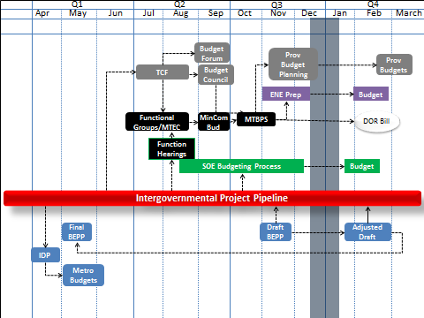

### Developing a strategy for prioritised Integration Zone/s

Once the priority Integration Zone(s) have been identified, the planning focus should shift to the development of a strategy for the prioritised Integration Zone/s – that is what is needed within integration zones and *how* will it be implemented to achieve the outputs and intermediate outcomes. The strategy should focus on both investment and non-investment interventions. The investment interventions are addressed under Capital Funding in section 3.4 below, while this section deals with the non-investment interventions.

The strategy should address issues such as public transport planning, identification of precincts, objectives for precincts and phasing, connecting the Integration Zone with the surrounds, land uses within the Integration Zone, development targets, especially for affordable and rental housing, land deals including swops, etc. within the Integration Zone (vs precinct level), public service delivery efficiencies, challenges and possible solutions.

Requirements and Expectations

Cities are required to demonstrate how they will use their land regulatory functions to achieve the type of development that should characterise Integration Zones (Outcome and Impact Indicators).

The Draft BEPP must outline what current land regulatory arrangements are in place within Integration Zones (if any).

The Final BEPP must outline what additional land regulatory arrangements are planned for the Integration Zones, or city wide.

Tools

The main tool to be used is the land regulatory functions that are assigned to cities in terms of SPLUMA and other legislation.

**SUPPORT**

The National Treasury CSP has launched a peer learning process to improve time required to get development approvals and other town planning regulator processes - best practices will be shared among the cities with a view to improving performance and thereby promoting development and growth.

There are a range of tools and instruments that are suitable for application in general and within Integration Zones and precincts viz. SPLUMA and related regulations to declare Integration Zones or Urban Development Zones and Social Housing Restructuring Zones. National targeting instruments such as Special Economic Zones, Industrial Development Zones, etc. can also be used.

Municipal By-laws are also a very effective tool if designed and applied in specific ways. There are a number of toolkits available from the Neighbourhood Development Partnership, and these are all available on the National Treasury website.

## Intergovernmental Project Pipeline

The intergovernmental project pipeline consists of both catalytic and non-catalytic projects within the metropolitan space whether it is a project of the national, provincial or metro government, or that of a public entity. The main purpose of the pipeline is for it to cover all spheres and entities to show collective public investment in particular spaces.

At present, most metros have limited information on plans and projects of other spheres and/or entities within their jurisdiction. This information is often only received when the spheres and/or entities apply for development approvals. This severely limits their ability to co-ordinate the implementation of these projects in relation to their own projects.

Requirements and Expectations

As the planning and project alignment improves with the introduction of the joint planning and budgeting process, all spheres and entities who have projects within metro spaces should be able to provide metros with their lists of projects (jointly agreed to capital projects over the medium term) to the relevant metro to include in their Draft and Final BEPP.

The Draft BEPP should have the template for the metropolitan project pipeline completed (Annexure 3).

The Final BEPP must have the projects of all spheres and entities as outlined in Table 1 below.

**Table 1: Intergovernmental Project Pipeline in Integration Zones**

|  |  |  |  |  |  |  |
| --- | --- | --- | --- | --- | --- | --- |
| Priority | Project Description | Municipal | Provincial | National | PRASA | Eskom |
| Integration Zone name | | | | | | |
| 1 | Station Upgrade |  |  |  | X |  |
| 2 | BRT | X |  |  |  |  |
| 3 | Bulk water works | X |  |  |  |  |
| 4 | Hospital redevelopment |  | X |  |  |  |
| 5 | Substation upgrade |  |  |  |  | X |
| City-wide projects | | | | | | |
| 6 | Social Housing |  | X |  |  |  |
| 7 | Police Station |  |  | X |  |  |
| 8 | Rail Extension |  |  |  | X |  |
| 9 | School |  | X |  |  |  |
| 10 | Land Development | X |  |  |  |  |
|  | **Value (Rand)** |  |  |  |  |  |

Tools

**The planning and reporting template for the** intergovernmental project pipeline has been refined for this cycle to focus on the current phase of the projects and is attached as **Annexure 3**. This template is required to be filled in and submitted as part of the BEPP and is directly linked to the criteria for accessing and receiving the ICDG (see ICDG grant framework in the DORA). As the project pipeline information improves over time it should inform the development of the long term financial strategy (section 3.3.1).

## Capital Funding

A Review of Local Government Grants started in 2014 to address issues of the miss-alignment of grants. Once completed, it should contribute to an improved alignment of grants that would complement the spatial targeting approach adopted by the cities in their BEPPs and thus support spatial transformation.

The budgeting process is regulated by the MFMA and has shown vast improvement over the last few years in terms of being medium term budgets that are funded, credible, relevant and reliable. Yet there is a need to go beyond legislative and regulatory compliance and have a long term financing strategy and plan at an institutional level which provides a framework for project-level financing of the metropolitan pipeline of catalytic urban development projects. The IDP, Budget and the BEPP of most cities currently do not focus on a long term financing strategy.

**SUPPORT**

The CSP is will provide support to cities to improve borrowing and investment strategies and develop long term financing strategy and plans.

There will be an annual technical desk-top review of BEPPs by the DBSA to assess how effectively and efficiently BEPPs are financed at an institutional and programme/project pipeline level.

The Urban Investment Partnership Conference in August 2015 that was used to showcase the catalytic urban development projects with a view to discussing financing options for these projects was the start of an ongoing dialogue between cities and investors.

Requirements and Expectations

BEPPs should clearly articulate the long term financing need and strategy for spatial transformation. This financing strategy should be based on the plan for spatial transformation – the spatial targeting approach that results in the identification of urban networks, Integration Zones, areas where service backlogs need to be addressed, informal settlements, marginalised areas, and growth nodes for economic development. The long term financial strategy provides the framework for investment activities that relate specifically to the financing of projects within Integration Zones (see sections 3.4 and 3.5).

The Draft BEPP should acknowledge the existence, or lack thereof of a long term financing strategy, and the Final BEPP must clearly state the commitment to the formulation of a long term financing strategy within a specific timeframe.

Tools

The CSP will hold a city-level workshop or series of workshops, or specific intervention on borrowing and investment to develop a long term financing strategy.

## Implementation

The planning, intergovernmental project pipeline and capital funding components of the built environment value chain have been elaborated on in the sections above and in previous BEPP Guidelines over the last two years. This Guideline for the 2016/17 BEPPs introduces the link to the *implementation* and *service delivery* activities of the built environment value chain.

There should be a direct and visible link between what is planned and budgeted, and what gets implemented and delivered, and how this contributes to a more sustainable, productive, inclusive and diverse city which will culminate in economic growth and a reduction in poverty and inequality. The implementation of capital projects should result in improved service delivery. Implementation also encompasses the procurement approach and risk mitigation (cash flow, time and quality). There are metros that are good at implementation, and there are metros that require some support with this.

Requirements and Expectations

There is an urgent requirement to move from project identification, preparation and financing to implementation of catalytic projects that result in improved service delivery. The expectation for 2016/17 is that a few key catalytic projects in the priority Integration Zone move from planning into implementation.

The Draft BEPP should identify all catalytic projects already in the implementation phase and those that will move into the implementation phase in 2016/17. The Final BEPP should contain the implementation arrangements/plans for the key catalytic projects in the Priority Integration Zone.

Tools

The tool available to cities to assist with infrastructure implementation is the Cities Infrastructure Delivery Management System (CIDMS) which will be phased in from the 2016/17 financial year.

## Urban Management

Urban management should result in good asset management and making spaces inclusive, valuable and useful at the human scale. This is generally best done at a precinct level. An Integration Zone will have a number of precincts within it.

Effective urban management requires a partnership approach. At the very least this involves a partnership between the metro and the people who reside and/or work in the area. Growth nodes (economic nodes) also require a specific kind of partnership e.g. City Deep in Johannesburg as part of the SIP 2 Freight Logistics Corridor or the Back of Port project in eThekwini. These partnerships are generally not easy to construct or manage.

Requirements and Expectations

Precincts will be identified with Integration Zones, and these precincts will require a plan for urban management. This is different to city-wide urban management initiatives.

The Draft BEPP should have the key precincts in the Prioritised Integration Zone(s) and growth nodes identified. The Final BEPP should confirm the establishment of these precincts so as to enable urban management to proceed

Tools

Urban Management should be done at a city-wide scale, and there should be a specific urban management approach for Integration Zone precinct management. Whether this is done via a management entity or not, it should include the attraction and retention of private fixed investment in terms of aligning and restructuring of economic development incentives as well as the removal of regulatory constraints to reduce financial risks and release land on to the market. It would also include a focus on the operations of public transport within the Integration Zone.

**SUPPORT**

The Neighbourhood Development Partnership Unit in the National Treasury has developed Precinct Management Guidelines. Pilot projects have commenced in the City of Johannesburg and Buffalo City. Discussions are also underway to extend this to eThekwini.

The department of Co-operative Governance (DCOG) has pledged support for the implementation plan for the priority Integration Zone in each metro.

# INSTITUTIONAL ARRANGEMENTS & OPERATING BUGETS

The current organisational structure of many metros can impede the implementation of transversal management priorities for effective service delivery. This does not mean that the organisational structure has to be changed, but rather those effective institutional arrangements for transversal management be established.

Requirements and Expectations

There is a need to outline cross cutting institutional arrangements in addition to specific institutional arrangements related directly to spatial planning, the project pipeline, capital budgeting, implementation or urban management that are outlined in sections of the BEPP. Cross cutting institutional arrangements should include the *linkages* between institutional arrangements for specific BEPP sections, and the implication thereof. The BEPP should provide a high-level description of the Operating Budget with specific reference to the sections of the BEPP where relevant.

The Draft BEPP should identify and acknowledge any existing institutional arrangements for addressing transversal management priorities for effective planning and implementation in Integration Zones, Areas of Growth, Informal Settlements and Marginalised Areas.

The Final BEPP should have a brief analysis of the effectiveness of these institutional arrangements.

# REPORTING AND EVALUATION

The overall value chain of built environment indicators (including activities, inputs, outputs, outcomes and impact indicators) now form part of a package of reporting reforms going through a rationalisation process to ensure a complete view of the planning and delivery system. This process intends to achieve the reduction of the reporting burden at activities, inputs and output level whilst introducing a limited set of indicators for outcomes and impact measurement. This multi-stakeholder reform process is underway.

Whilst this comprehensive view of the full value chain is necessary, it is important to note that reporting on activities, inputs and outputs indicators will be through the normal SDBIP, Section 71 and 72 processes, whilst the outcomes indicators are linked to the ICDG and thus will be reported through the BEPP. In addition, the activities, inputs and output indicators will be subjected to the oversight of the Auditor-General whereas the outcomes and impact indicators will not. National consultations on all these indicators will be finalised at the end of October. A final set of indicators will not be ready for inclusion on the Draft BEPPs for the 2016/17 MTREF on 3 November 2015. Metros will get another opportunity to refine and consult on the draft indicators by the 30 October 2015.

Requirements and Expectations

To ensure proper institutionalisation of the process within each metro, this process of indicators need to be jointly held up by the CSP focal points and the performance management, IDP Units in metros to ensure proper management of the transition. The work on the indicators and reporting reforms will be concluded in mid-November 2015 and the development of baselines and targets should be completed in time for inclusion and discussion during the BEPP Review Process in Jan-Feb 2016 and for inclusion in the final Council-approved BEPP by the end of May 2016.

# BEPP PROCESS AND TIMEFRAMES

Key Dates

The draft BEPP is due on **3 November 2015**, and the final BEPP approved by Council is due on **31 May 2016**. The Annual Evaluation of BEPPs is scheduled for **22 June 2016** and the discussion on the 2017/18 BEPP Guidelines is scheduled for **13 July 2016**, with the approved Guidelines planned to be issued by **29 July 2016**.

Alignment of BEPP, Budget and IDP Processes

Alignment of BEPP Review and Mid-Year Budget Review in 2015/16 worked well and will now be institutionalised. The Department of Cooperative Governance has committed to align the IDP Assessment to the Budget and Benchmarking process, where Day 1 is dedicated for the IDP Assessment and alignment of the BEPP and IDP, and Day 2 is for the Budget Benchmarking. Proposed dates for 2016 are outlined below, and agreement on the dates will be in place by the beginning of December 2015.

|  |  |
| --- | --- |
| **2015/16 MTREF Mid-Year Budget and Performance including 2016/17 MTREF BEPP Review** | |
| **Metro** | **Date** |
| City of Johannesburg | 25 & 26 January 2016 |
| Ekurhuleni | 28 & 29 January 2016 |
| City of Tshwane | 01 & 02 February 2016 |
| Buffalo City | 04 & 05 February 2016 |
| eThekwini | 08 & 09 February 2016 |
| Nelson Mandela Bay | 11 & 12 February 2016 |
| Mangaung | 15 & 16 February 2016 |
| Cape Town | 18 & 19 February 2016 |

|  |  |  |
| --- | --- | --- |
| **2016/17 MTREF Municipal Benchmark Exercise**  **Budget Council Room, 40 Church Square, Pretoria,**  **09:00 To 17:00** | | |
| **Metro** | **Meeting Date** | **Venue** |
| eThekwini | 18 & 19 April 2016 | Budget Council |
| City of Cape Town | 20 & 21 April 2016 | Budget Council |
| City of Johannesburg | 25 & 26 April 2016 | Budget Council |
| Ekurhuleni | 28 & 29 April 2016 | Budget Council |
| City of Tshwane | 03 & 04 May 2016 | Budget Council |
| Mangaung | 05 & 06 May 2016 | Budget Council |
| Buffalo City | 09 & 10 May 2016 | Budget Council |
| Nelson Mandela Bay | 11 & 12 May 2016 | Budget Council |

# GUIDELINES FOR CONTENT AND FORMAT REQUIREMENTS

| **Sub-Section of BEPP** | **Key Content Requirement** | **Relation to Old Format/Content** |
| --- | --- | --- |
| **A. Introduction** | |  |
| **BEPP in relation to other Statutory Plans** | Standardised section on Role of the BEPP,  A list of the documents and references used in compiling the BEPP, and a statement confirming the adoption of the BEPP by Council with a copy of the Council Resolution in Annexure. | Old Part A |
| **B. Spatial Planning and project prioritisation** | Old Part B on the Strategic Review of the Built environment Infrastructure can be a separate document that can be updated from time to time and read in conjunction with the BEPP. The main objective of the old Part B was to show the impact of sector trends and demands on spatial form in terms of convergence or divergence from compact urban form. | |
| **B1 Spatial Targeting** | Spatial Development Strategy   * Urban Network identification and prioritisation of Integration Zones * Marginalised areas (Informal settlements, Townships and Inner City Areas) identification and prioritisation * Growth nodes (commercial and industrial) identification and prioritisation | Summarise Old part C1-C3  Old Part C4.1  Sub-section of old Part B4  Old Part B2 |

| **Sub-Section of BEPP** | **Key Content Requirement** | **Relation to Old Format/Content** |
| --- | --- | --- |
| **B2 Local Area planning** | * Integration Zone plans, precinct plans and local area plans for the 3 spatial targeting categories (See B1): | Old Part C4.1  Old Part C4.1  Sub-section of old Part B4 |
| **B3 Project Preparation** | * Project preparation for key, non-standard, complex projects and for projects that require external financing * Fiscal impact assessments/Capital Projects Assessment by National Treasury for selected projects |  |
| **B4 Institutional Arrangements and Operating Budget** | * Planning alignment between BEPP, IDP and SDF * As per B2, including the private real estate and finance sectors | Old Part E4 |
| **C. Intergovernmental Project Pipeline** | | |
| **C1 Intergovernmental pipeline** | * Prioritised projects for each of the 3 spatial targeting categories (See B1) * High level cost estimates for all projects | Old Part s of C4.4 – C4.7 and E5, E6, E7, E8, E9, and project pipeline template |
| **C2 Institutional Arrangements and Operating Budget** | * Leadership, good governance and planning (strategic & operational) * Inter-sectoral municipal & consultation with PG, SOE’s & National Departments responsible for asset creation for service delivery directly to the public (e.g. SAPS) * Risk mitigation strategies * Operating budget implications   City Support Implementation Plan | Old Part s E1-E4 |

|  |  |  |
| --- | --- | --- |
| **Section of BEPP** | **Key Content Requirement** | **Relation to Old Format/Content** |
| **D. Capital Funding** | |  |
| **D1 Spatial Budget Mix** | * High level allocation of capital budget to each of the 3 spatial targeting categories in terms of total capital budget from all funding sources (see B1) | Old Parts E5 – E9 |
| **D2 Investment strategy** | * Investment strategy for intergovernmental project pipeline |  |
| **D3 Institutional Arrangements and Operating Budget** | * Leadership, good governance and planning (strategic & operational) * Inter-sectoral municipal & consultation with PG, SOE’s & National Departments responsible for asset creation for service delivery directly to the public (e.g. SAPS) * Risk mitigation strategies * Operating budget implications * City Support Implementation Plan | Old Parts E1 –E4 |
| **E. Implementation** |  |  |
| **E1 Land release strategy** | * Approach to land release for top priority projects with land implications | Sub-section of Old Part C3 |
| **E2 Procurement approach** | * Procurement approach for top priority projects | Old part E3 |
| **E3 Institutional Arrangements and Operating Budget** | * Leadership, good governance and planning (strategic & operational) * Inter-sectoral municipal & consultation with PG, SOE’s & National Departments responsible for asset creation for service delivery directly to the public (e.g. SAPS) * Risk mitigation strategies * Operating budget implications * City Support Implementation Plan |  |

|  |  |  |
| --- | --- | --- |
| **Section of BEPP** | **Key Content Requirement** | **Relation to Old Format/Content** |
| **F. Urban Management** | |  |
| **F1 Urban Management** | * Precinct management approach for Integration Zone precincts and Growth Nodes. * Key land use management interventions * Private sector investment approach, including the alignment and restructuring proposals for incentives | Old Parts C4.4 – C4.7 |
| **F2 Transport management** | * Transport management approach to Integration Zone routes |  |
| **F3 Institutional Arrangements and Operating Budget** | * Precinct management entities * Linkage between municipal service delivery and precinct management entities |  |
| **G. Institutional Arrangements & Operating Budget** | |  |
| **G1 Cross Cutting Institutional Arrangements** | * Institutional arrangements that do not form part of a specific BEPP Section * Highlighting the linkages between institutional arrangements for specific BEPP Sections and the implications thereof |  |
| **G2 Consolidated Operating Budget** | * High-level description of the Operating Budget, with specific reference to the BEPP Sections |  |
| **H. Reporting & Evaluation** | |  |
| **H1 Reporting and Evaluation** | * Consolidation of all the individual BEPP Sections into a Theory of Change * Reporting on the actuals from the previous BEPP |  |

# Annexure 1: Built Environment Progression Model

**Introduction**

Having been a requirement for two financial years thus far, BEPPs have evolved to be regarded by metros as an important, valuable and strategic planning instrument. There has been progressive realisation of the intention of the BEPPs as a planning instrument for spatial targeting linked directly to capital funding and expenditure. Given the varying capacities and capabilities of the eight metros, progress in terms of the quality of the content of the BEPP and the rigour of the BEPP process has been uneven across the metros.

It has been argued that a progression model might prove useful in plotting the development of cities in their development of BEPPs.

**What is a progression model?**

Progression models, sometimes called maturity models, have been introduced to the public sector increasingly over the last decade. They are based on a developmental view of the public sector, appreciating that excellent performance is not arrived at overnight, particularly in big organization’s such as our metropolitan municipalities. Progression models provide incremental steps.

Most importantly, they provide a rational basis for differentiated responses, whether these are support or incentives. Unlike most systems of performance measurement, they accommodate qualitative assessments though instruments like rubrics. This approach can incorporate an element of self-assessment which ensures a greater ownership of the assessment.

**Conceptual Elements**

This section attempts to describe how a progression model could be used to assess BEPPs.

**Purpose**

To provide a rational, evidence-based and holistic assessment of Cities’ BEPPs to inform a specific assessment of their needs and to guide differentiated support and incentives.

**Scope**

The scope of this assessment is to assess each of the BEPPs of metropolitan municipalities over successive annual cycles with respect to

* The process of formulating its BEPP
* The quality and content of the BEPP
* The institutionalisation of the BEPP

Institutionalisation refers to the degree to which the BEPP has become embedded in plans and practice in the metro. However it does not refer to full, longer term implementation of the BEPP, as there is expected to be a multi-year lag between a BEPP and its implementation that will contribute to outcomes and impact. The implementation of the BEPP is an important consideration, but it is not practical to be included in the progression model. However the incremental building of the BEPP to be a medium term plan and progressing to be longer plan with a planning horizon to 2030 is part of the progression model. There is also an important causal relationship that is hypothesised between the quality of the BEPP, implementation of the BEPP and the attainment of desired built environment outcomes within the city.

While directly outside of the scope of this progression model, the extent to which the BEPP is implemented and desired built environment outcomes achieved, remain key questions, when evaluating the success of BEPPs as an instrument. The CSP is working with metros to address this challenge, and once the project on Indicators and Reporting Reforms is completed, this will become evident.

**Key elements**

Progression scale

While some progression and maturity models allow for a scale (or categorisation ) of six or more points, a four-point scale is recommended for simplicity and alignment with other successful public sector progression models such as MPAT and LGMIM.

Structure

It is proposed that there are key areas for assessment:

* The process of formulating its BEPP
* The quality and content of the BEPP
* The institutionalisation of the BEPP

These are to be broken down into a set of standards that explicitly define the expectation (level 3). A rubric will define what a level 1, 2, 3 and 4 looks like for each of these standards.

An assessment can be calculated through a system of weights to be applied at the level of standards or assessment areas. These weights can shift over time. For example there might be greater emphasis on the BEPP process and plan for now, allowing for a greater shift to BEPP institutionalisation in future years.

Self-assessment

It is proposed that self-assessment provide the initial basis for assessment, in order to ensure that metros own the assessment. This will ideally be done as part of a facilitated internal dialogue by the core team responsible for the BEPP, but at the very least must involve officials from sectors or line functions, planning, finance and M&E.

Use of evidence

To complement the self-assessment, evidence for the assessment on each standard will need to be provided.

Independent Expert assessment

To moderate and ensure consistency between cities, an expert can be utilised to consider the evidence and moderate the self-assessment. This can be done in dialogue with the metro or independently.

**Assessment Framework**

BEPP level

The assessment framework is suggested to be structured as portrayed in the incomplete matrix below.

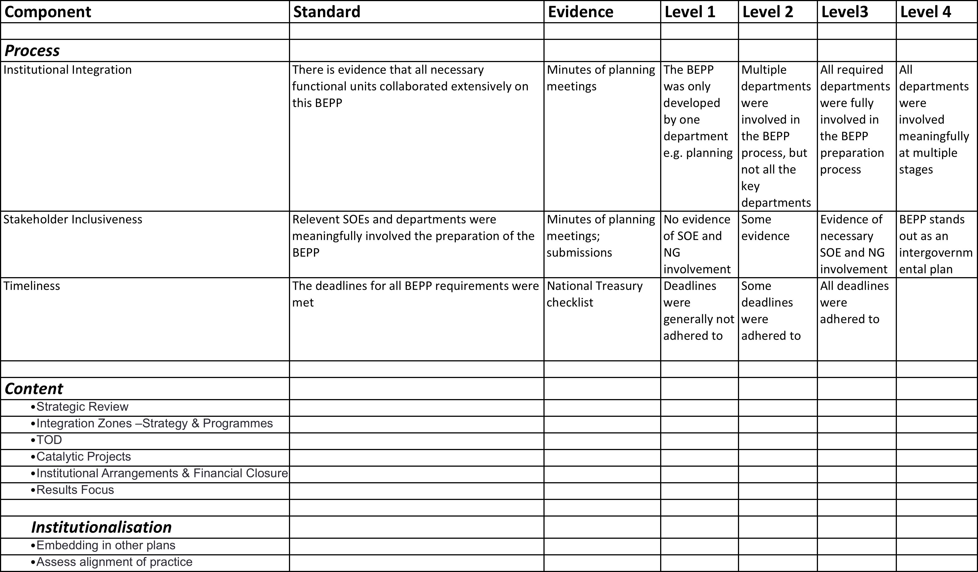

Please note that this assessment framework is being developed

Drilling Down

One metro has suggested drilling down in the application of the progression model. This implies that a similar and specific assessment framework can be developed for integration zones and another for catalytic projects. In this way the metro will be able to track the progression of its integration zones and catalytic projects. The aggregate progression of catalytic projects and integration zones can be reflected in the appropriate components of the BEPP. City officials have argued that this disaggregation will be useful to monitor the progression or maturity of their catalytic projects.

**Process**

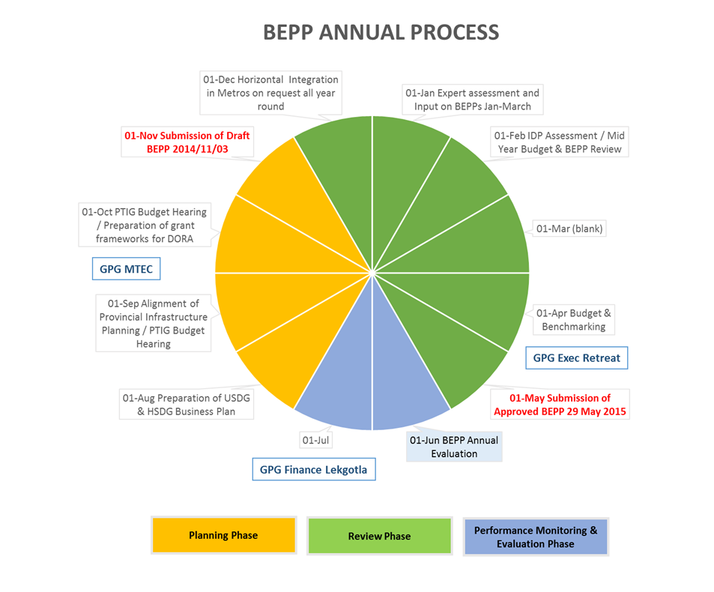

It is proposed that the BEPP progression model is applied in the BEPP Annual evaluation and reflection process to take place in June and July of each year.

It will need to involve the following steps:

* Distribution of the BEPP Assessment Tool by CSP
* Self-Assessment by city teams
* Submission to CSP
* Collation of assessments
* CSP to appoint independent expert assessors
* Moderation / Independent Assessment
* Feedback discussions with cities and independent assessors
* Consolidation of results and analysis – lessons learnt

**Results**

Cities should receive a report card on their BEPP (process, plan, and institutionalisation) that ideally should inform their improvement planning. A diagnostic analysis across metros will also be useful to inform the types and level of support to be provided by Treasury and sector departments.

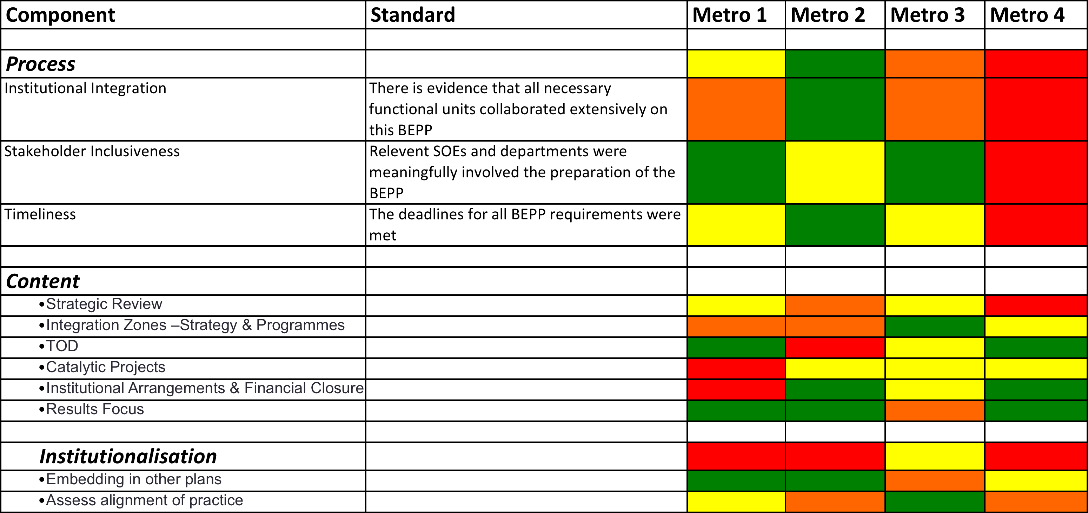

**Outcome of the Assessment**

The outcome of the BEPP progression assessment should inform

* Learning and improvement by the metro for subsequent BEPP processes
* Support provided by national government, especially that of CSP, to each metro in relation to its BEPP process
* Incentives for improvement of BEPPs

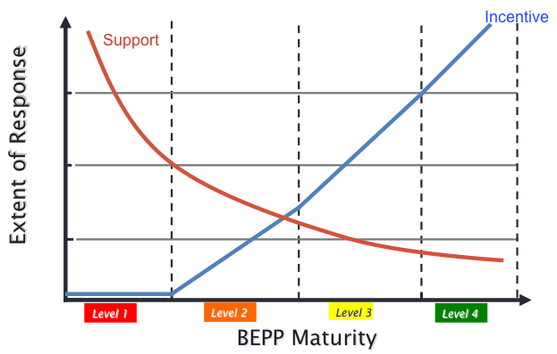

The incentive proposed may be grant related and could form a portion of the ICDG or additional grant. There is some debate about whether the ICDG should be used for this. It is argued that while built environment outcome indicators are still nascent and not fully tested a significant part of the ICDG could be determined by BEPP progression. The extent of this component could reduce over subsequent years to provide a greater allocation for that determined by the achievement of built environment outcomes.

# Annexure 2: Integration Zones Matrix



# Annexure 3: Catalytic Urban development Project Pipeline Template

|  |  |  |  |  |  |  |  |
| --- | --- | --- | --- | --- | --- | --- | --- |
| Catalytic Urban Development Project Pipeline Template | | |  |  |  |  |  |
| PROJECT DESCRIPTION | | | | | | | |
|  |  |  |  |  |  |  |  |
| **Name of Integration Zone** | **Network Element** | **Name of Precinct** | **Name of Project** | **Description of project** | **Location** | **Type (e.g. Residential)** | **Yield (Quantity)** |
|  |  |  |  |  |  | As Per Guideline | As per Guideline |
|  |  |  |  |
| [Insert name of Integration Zone] | |  |  |  |  |  |  |
|  | **Hub** |  |  |  |  |  |  |
|  | [Insert name of Hub] |  |  |  |  |  |  |
|  |  | [Insert name of Precinct] |  |  |  |  |  |
|  |  |  | [Insert name of Project] |  |  |  |  |
|  |  |  |  |  |  |  |  |
|  |  |  |  |  |  |  |  |
|  | **Corridor** |  |  |  |  |  |  |
|  | [Insert name of Corridor] | |  |  |  |  |  |
|  |  | [Insert name of Precinct] |  |  |  |  |  |
|  |  |  | [Insert name of Project] |  |  |  |  |
|  |  |  |  |  |  |  |  |
|  |  |  |  |  |  |  |  |
|  |  |  |  |  |  |  |  |

|  |  |  |  |  |  |  |  |  |  |  |  |  |
| --- | --- | --- | --- | --- | --- | --- | --- | --- | --- | --- | --- | --- |
| PROJECT OUTCOME | |  | PROJECT PROCESS | | | | | | | | | |
|  |  |  |  |  |  |  |  |  |  |  |  |  |
| **Project Impact (E.g. Fiscal)** | **Project Demand** |  | **Current Stage in the Project Cycle** | **Estimated Total Project Cost** | **Funding Received** | **Source of Funding** | **Funded What** | **Funding Requested** | **Source of Funding** | **To Fund What** | **Project Manager** | **Key Dependencies** |
| As per Guideline | Evidence of Effective Demand |  | As per PPF Policy Framework |  |  |  |  |  |  |  |  |  |
|  |  |  |  |  |  |  |  |
|  |  |  |  |  |  |  |  |  |  |  |  |  |
|  |  |  |  |  |  |  |  |  |  |  |  |  |
|  |  |  |  |  |  |  |  |  |  |  |  |  |
|  |  |  |  |  |  |  |  |  |  |  |  |  |
|  |  |  |  |  |  |  |  |  |  |  |  |  |
|  |  |  |  |  |  |  |  |  |  |  |  |  |
|  |  |  |  |  |  |  |  |  |  |  |  |  |
|  |  |  |  |  |  |  |  |  |  |  |  |  |
|  |  |  |  |  |  |  |  |  |  |  |  |  |
|  |  |  |  |  |  |  |  |  |  |  |  |  |
|  |  |  |  |  |  |  |  |  |  |  |  |  |
|  |  |  |  |  |  |  |  |  |  |  |  |  |
|  |  |  |  |  |  |  |  |  |  |  |  |  |
|  |  |  |  |  |  |  |  |  |  |  |  |  |